UMass Boston Records Database User Guide
records.umb.edu

The online records database is a straightforward and efficient way to manage and view all UMB records being stored on or off campus and to ensure compliance with the records management policy and standard retention schedules. The database can be accessed at records.umb.edu or through the Contracts & Compliance webpage.

Each department’s records custodian will be able to log in and use the database after being registered by a Contracts & Compliance staff member and attending training. The online registration form includes the records custodian’s name, email address, phone number, and the department(s) they will be managing records for.

After a records custodian is registered, they will receive an email notifying them that they are able to access the database. Upon access they must use the “forgot your password?” link at the bottom of the login page, which will email them a link allowing them to set their password. This can be the same as their UMB email password or something different. Once their password is set, users can log in using their email address as their username.

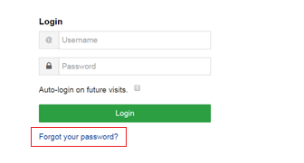

If a user forgets their password, they can repeat the above process at any time. Their password can also be changed through the “my account” page at the top right of the database screen.

Records custodians will be able to search for records and create new records and reports. These functions are easily accessible at the top of the webpage. Records custodians will only be able to create and edit records for their own department(s), but can view the records for all departments.

To enter a record, the records custodian should select the “create a record” tab at the top of the page. This will open the record entry form.

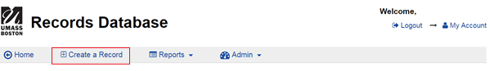

The form has 23 different fields, most of which have help icons next to them that bring up explanatory text boxes. All required fields are marked by red asterisks. The fields are:
- Title: This is the record name, which should be created by adding the record sub-category name and the records’ date range (e.g. Fiscal Audit Records, 2014-15).
- Responsible Department: Clicking on this field will open a drop-down list of departments, from which the records custodian will select their department.
- Record Type, Record Category, and Record Subcategory: These three fields are the record’s location on the UMB standard retention schedules, for example:
  - Type: A (Administration)
  - Category: A1 (Program Development and Review)
  - Sub-Category: A1-1 (Academic Program Establishment)
Note: When the user selects the record type and category, the category and sub- category fields (respectively) fill automatically with specific records to choose from.

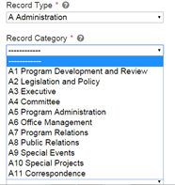

Note: Selecting the record sub-category causes a record description from the UMB standard schedules to automatically appear on the screen.

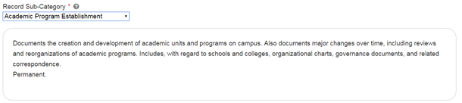
- Record Form: Records can be either original or copies. For the most part, the records being stored should be originals.
- Record Media: “Paper” is automatically selected for this field.
- MA Standard Retention Schedule: This is the retention period from the UMB standard schedule, as required by the state. This field fills with relevant selections when the record sub-category is chosen.
- Federal Retention Schedule: Most UMB records will not have federal retention requirements and this field can be left blank.
- Federal Retention Schedule # of Years: If a record does have federal retention requirements (a common example is grant records) the required retention period can be entered here.
- Retention Schedule Begins: Clicking on this field opens a drop-down menu of choices for a retention schedule’s start, for example “when administrative use ceases.” The appropriate selection for each record can be found by looking at the UMB standard schedules.
- Retention Schedule Begins on: This is the date that the retention requirements began for the records. When clicking on this field, a calendar box will open. A date can also be typed into the box if easier.

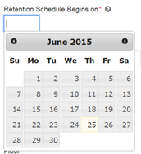

Note: When entering a box of records with more than one starting date, the most recent date should be entered to ensure all records comply with the standard schedule.
- Box Number: Each department should come up with their own numbering scheme for their boxes, each of which must have a unique number. The characters must be numbers and include the department code.
- Fiscal Years Stored Onsite: The number of years the records will be stored on campus.
- Building, Floor, and Room #: Where the records are stored on campus.
- Fiscal Years Stored Offsite: The number of years the records will be stored offsite. If the records will not be stored offsite, “0” can be chosen.
- Offsite Location: The offsite storage location of the records, for example Iron Mountain or the state records center. This field should include the location’s name and address. If the records will not be stored offsite, the records custodian should enter “N/A” or leave the field blank.
- Personally Identifiable Information: Either yes or no can be chosen for this field. Records with Personally Identifiable Information (PII) contain information which could harm the privacy of individuals or the security or proprietary business of UMB. An example of PII is a social security number.
- Method of Destruction: This field will fill automatically based on the selection for PII. If yes, the records will be shredded; if no, they will be recycled.
- Is this document destroyed? Records custodians can check yes or no. When entering new records the choice should be no, which is set as the default option. The database will automatically calculate a destruction date, which can be seen when viewing the record entry.
- Notes/Comments: A text box is provided where the records custodian can enter additional information about their records.

After submitting a record entry form, the records custodian will be able to review the information they’ve entered and make any edits necessary. Entries can also be edited after submission by selecting the “edit” option, either when viewing a list of records or a specific record page.
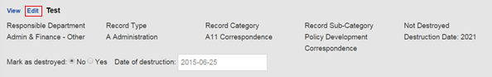
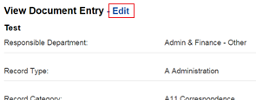

Records are searchable within the database by keyword (which includes the notes field); record type, category, and sub-category; department; and whether or not they have been destroyed. The search option is featured on the home page. After performing a search, a list of matching entries is displayed.
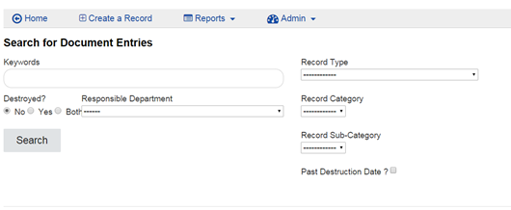

Records custodians are able to mark records as destroyed by checking “yes” next to “mark as destroyed” on the records list and then selecting “submit destroyed records” at the top or bottom of the search results. Records can also be marked as destroyed on their general edit page. When marking a record as destroyed the date will automatically be set to the day the edit was made, but this can be changed.
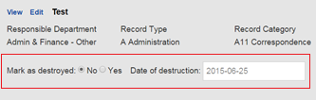

Another function of the database is creating reports. These can be accessed by selecting the “Reports” tab at the top of the page and choosing “Record Report.”
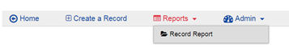

Reports can be created based on record type, responsible department, and whether or not the records have been destroyed or are due for destruction. They are downloaded as Excel spreadsheets.

