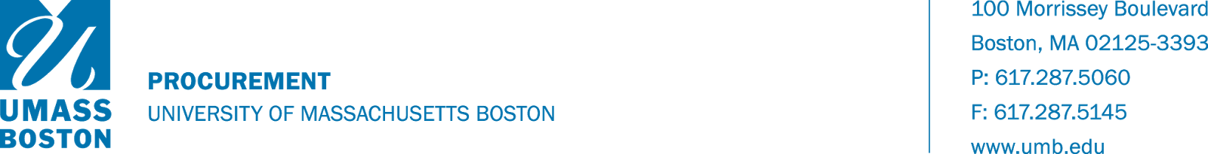
RECORDS DISPOSAL AUTHORIZATION
Contact Information:
DEPARTMENT: | DATE:
PERSON COMPLETING FORM: | CONTACT PHONE NUMBER OR EMAIL:
RESPONSIBLE DEPARTMENT: | RECORD CUSTODIAN:

Acknowledgment of Disposition:
I hereby authorize the disposal of all the records listed below that are not retained by University Archives:
Custodian: ____________ Date:

Disposition of Records:

Transferred to Archives by: __________________________ Date: _____________

Destroyed by: ______ Date:
Record Description:
Box No | Brief Description | This box contains ONLY Financial / Personnel / Student Records (Y/N)  [Will be shredded] | This box contains other types of records  (Y/N)  [Will be reviewed by Archives and then either retained, shredded or recycled]
Contact Information:
DEPARTMENT: | DATE:
PERSON COMPLETING FORM: | CONTACT PHONE NUMBER OR EMAIL:
RESPONSIBLE DEPARTMENT: | RECORD CUSTODIAN:

Record Description:
Box No | Brief Description | This box contains ONLY Financial / Personnel / Student Records (Y/N)  [Will be shredded] | This box contains other types of records  (Y/N)  [Will be reviewed by Archives and then either retained, shredded or recycled]

