University of Massachusetts Boston
Variance Report Guide & Instructions

Timeline
At the end of each quarter an automated mailer will deliver a variance report template to each budget manager generated from the Summit system. Users can also access the variance report in the Summit system to analyze the data and break it down to lower department levels if desired.
Overview
Variance reporting templates provide a few key pieces of information. Each report comes complete with spend and revenue year-to-date (YTD) for this year and prior year, and expense encumbrances YTD. There is also the full year budget load at the time of the report. Lastly, there are columns showing current year YTD actuals vs prior year YTD actuals, current year YTD actuals and encumbrances vs. current year full year budget, and current year YTD actuals vs a current year YTD budget. The current year YTD budget is calculated by using prior year expense trends vs. the current year full year budget, for the final quarter of the year (Q4) the YTD budget is equal to the full year budget.
Funds included are as follows:
- State/Tuition/GOF
- NTT
- RTF
- ESS
- Lab Fees
- Parking Operations
Variance Explanation Guidelines
The variance reports have a specific structure and indicate which variances require explanation. The columns in the reports are:
- College/Unit
- Budget Area
- Fund
- Account Group (sometimes referred to as subsidiary)
- Prior Year YTD actuals (Expressed as FYXX QX)
- Prior Year Full Year actuals (Expressed as FYXX)
- Current Year YTD (Expressed as FYXX QX)
- Current Year YTD Budget (Expressed as FYXX QX Budget)
- Current Year YTD Encumbrance (Expressed as FYXX QX Encumbrance)
- Current Year Full Year Budget (Expressed as FYXX QX Budget)
- Current Year YTD Budget Variance (Expressed as FYXX QX Budget Variance)
- Current Year YTD Budget Variance % (Expressed as FYXX QX Budget Variance %)
- Current Year Committed vs Current Year Budget (Expressed as FYXX Committed vs FYXX Budget)
  - This field shows an area’s expenses and encumbrances YTD vs the full year budget
- Current Year YTD Budget Explanation Required (Expressed as FYXX QX Budget Explanation required)
  - This field will either read yes or no. If yes explanation is required.
- Current Year YTD Budget Explanation (Expressed as FYXX QX Budget Explanation)
  - This field will always appear blank, it is where the budget managers will enter an explanation if required. Areas explain YTD actuals vs the calculated YTD budget here.
- Current Year YTD vs Prior Year YTD Explanation required (Expressed as FYXX QX Explanation required)
  - This field will either read yes or no. If yes explanation is required.
- Current Year YTD vs Prior Year YTD Explanation (Expressed as FYXX QX Explanation)
  - This field will always appear blank, it is where the budget managers will enter an explanation if required. Areas explain YTD actuals vs the same period in the prior year here.
- Full Year Budget Explanation Required
  - This field will either read yes or no. If yes explanation is required.
- Full Year budget Explanation
  - This field will always appear blank, it is where the budget managers will enter an explanation if required. Areas will explain current year expenses and encumbrances YTD vs the full year budget here. In Q4 this is duplicative with the Current Year YTD Budget Explanation field.
The criteria for explanation for current year YTD actuals vs current year YTD budget or prior year YTD actuals is any variance exceeding +/- $10,000 and 10%. The criteria for explanation of current year YTD actuals and encumbrances vs current year full year budget is any variance that exceeds budget tolerance.
Variance explanations should include some sort of operational change, not simply just re-hashing the decrease/increase amount but rather pointing out specific operational differences vs the prior year/current year budget. The explanation should also include whether or not a budget area believes the variance shows a risk in the current year or potential future years to achieving budget.
Variance explanations should be filled out in the attached excel file automatically sent to budget areas and returned to OBFP before the date specified in the automatically generated email.
Summit Variance report dashboard
The variance reports will be sent by email to business managers through a client in Summit, however the reports can also be accessed through Summit.
From the Summit dashboard choose the “Department Management” selection on the following web page:
https://analytics.umassp.edu/analytics/saw.dll?Dashboard

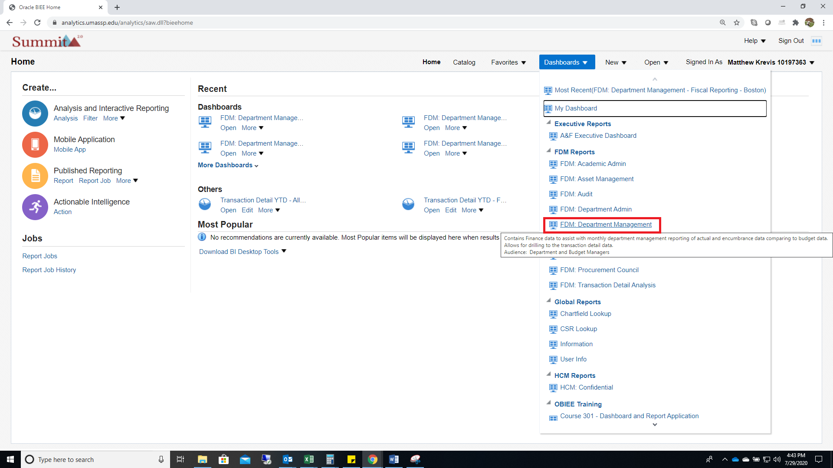

After selecting “Department Management” select “Business Managers”
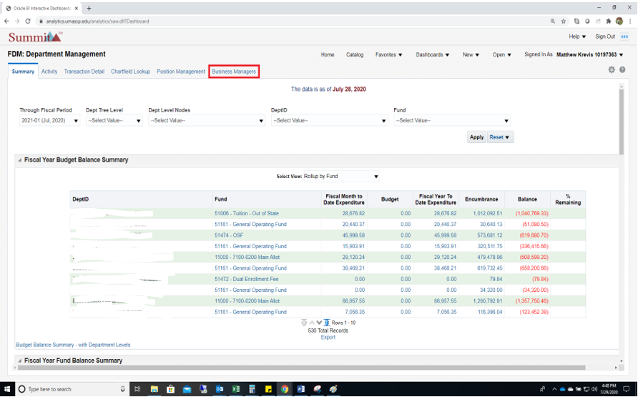

After selecting “Business Managers” select “Quarterly Variance Reports”

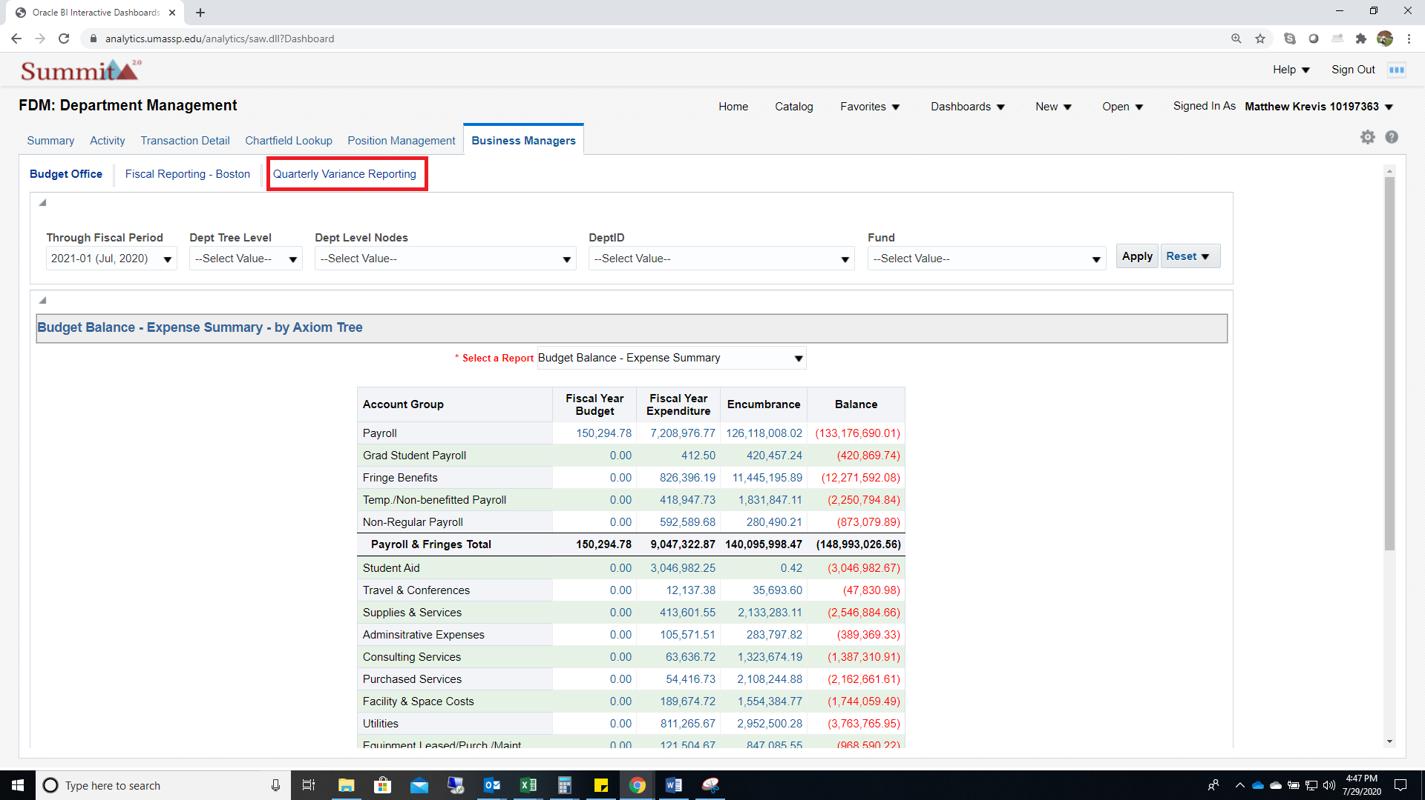

Once in the “Quarterly Variance Reports” dashboard use the dashboards to select the corresponding quarterly ending period and College/Unit (if applicable, most users will only have one option in College/Unit). The quarterly ending periods are expressed by the fiscal year followed by the month they end in (03, 06, 09, or 12)
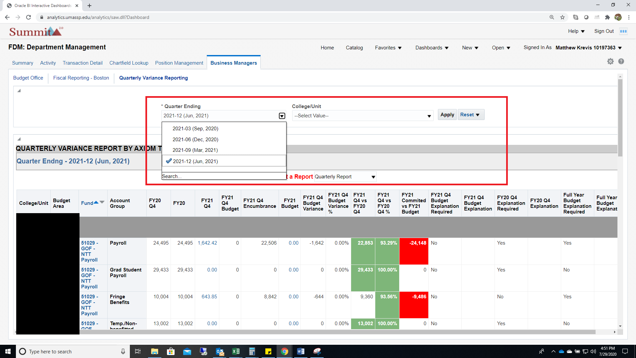

Variance reports are due back at the level the client has sent them out, however if you would like to see more detail to get inputs from lower level department managers to assist you in completing the high level template, you can filter down to a view that shows the detail by department by using the “Select a Report” section and selecting “Quarterly Report by Dept”

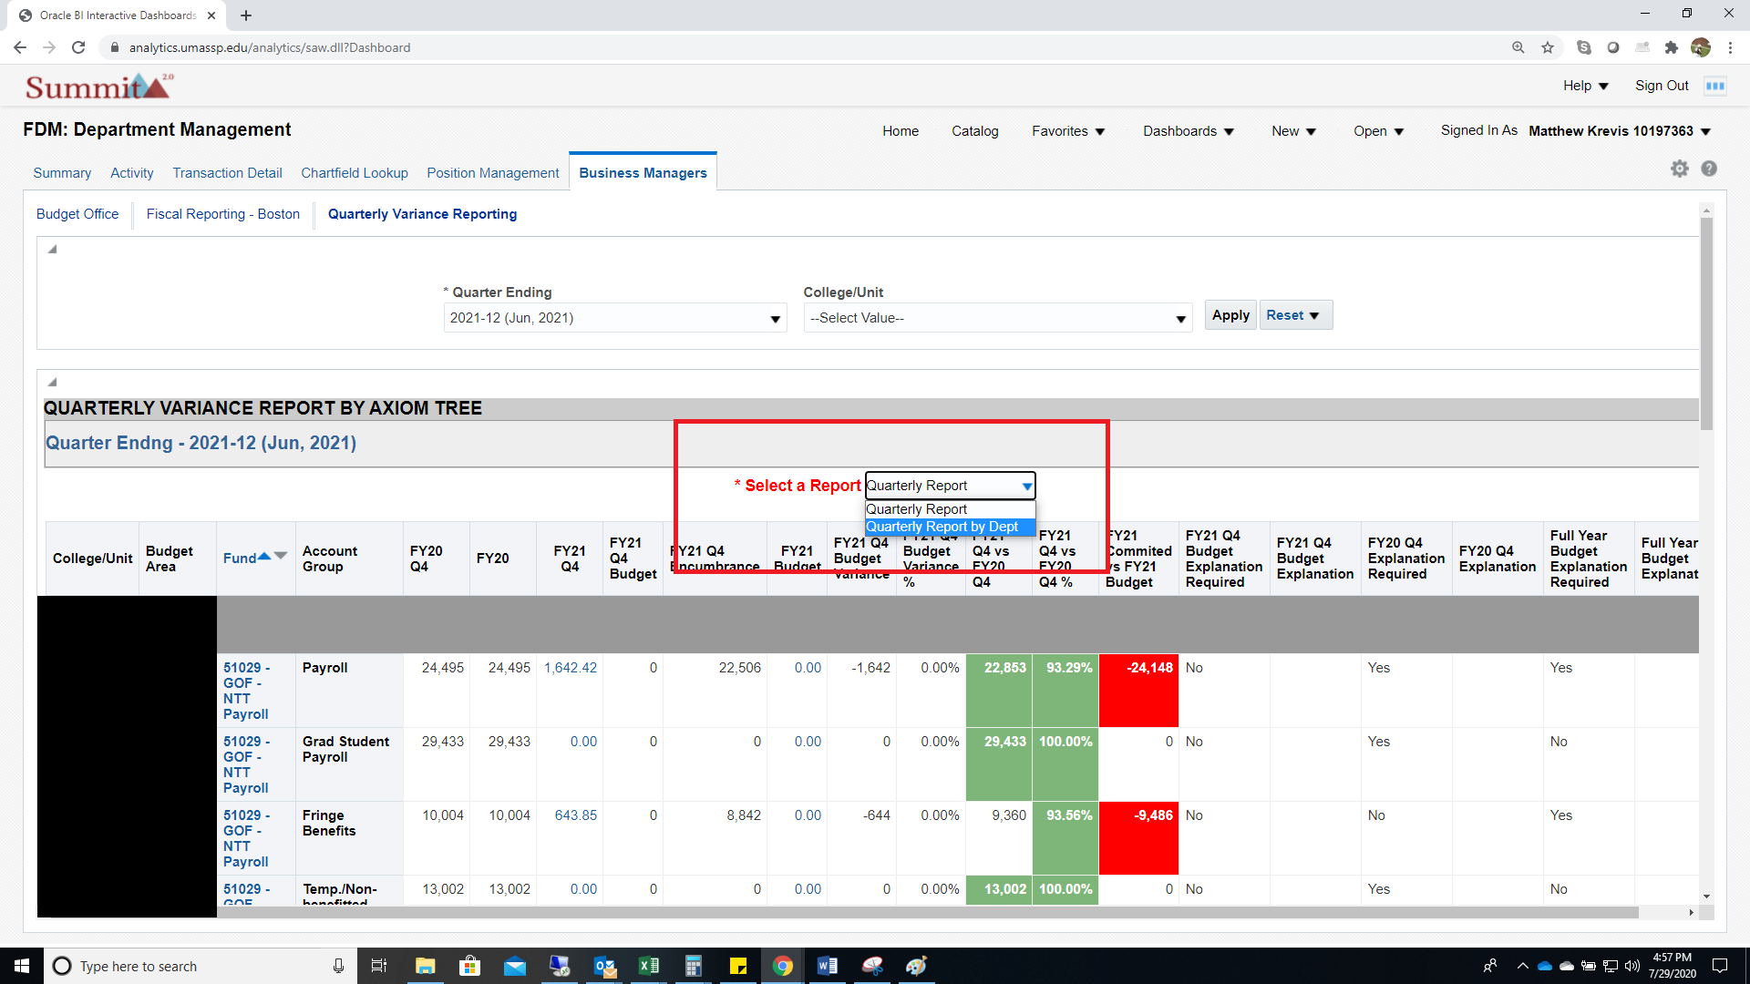

If you want to export a more detailed version to excel you can use the export function at the bottom of the report. This can be useful if you want to send a lower level detail report to a specific department in your directorate.
