Campus Center & Event Services
Workstation/Physical Space Key Request Form

General Information:
Today’s Date: | Department Name:
Requestor’s Name: | Phone Number:
Email Address: | UMass Boston ID:

Campus Center location:
Floor #: | Room/Cubicle #:

Type of Key Requested:
Workstation Keys
Includes desks, cabinets and overhead bins. Please note workstation keys are non-transferable and must be returned to the Campus Center & Event Services department by a transferring or exiting employee.
 | New | Lost | Damaged | Dept./Location Change
 | Key # (Ex: K###):

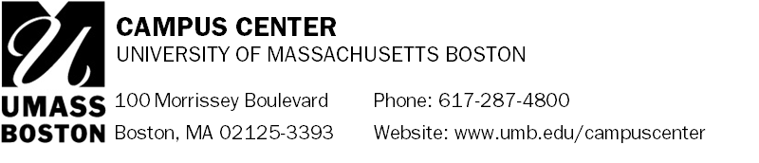
Physical Space Keys
Please note the Campus Center will complete a Key Request Form through the Facilities Department on your behalf. The physical space keys are managed by the Facilities Department and must be picked up and returned to the Facilities Service Center located in the Service and Supply Building, Upper Level, Room 001.
 | New | Lost | Damaged | Dept./Location Change
 | Floor and Room Number:

Department Head or Office of Student Life Authorization:
By signing below, I authorize this individual to receive keys to a Campus Center workstation or physical space.
Name (Print): | Signature: | Date:

OFFICE USE ONLY
Signature of CC Personnel Issue Key(s): Date:

Notes:

Please send the completed form to: Campus Center & Event Services
(Office) Campus Center, UL 330 | (Phone) 617.287.4800 | (E-mail) campus.center@umb.edu

